**Topic:** Eratosthenes

**Notes on Topic:** After Archimedes left his long shadow cast on the world of mathematics, few mathematicians measured up   
Syracuse fell to the Roman Marcellus in 212 BC, three bloody Punic wars ended with Rome’s destruction of its rival Carthage in 146 BC, ensuring Roman controlling on both sides of the Mediterranean, that same year, the last Greek city, Corinth, yielded to Roman power.   
A century later Julius Caesar conquered Gaul in 30 BC, and after the unsuccessful stand of Anthony and Cleopatra, Egypt fell to the Romans at the hands Octavian. Barbarian Britain came under Roman control in 30 AD.  
Rome was now officially an empire, they had domination over the western world.  
Roman conquest brought sophistication to the world of engineering, with bridges and roads and aqueducts traversed the European landscapes, but the abstract, pure mathematics world was left untouched as it had been by the former glorious Greek men.  
  
The great Library of Alexandria was left untouched, and there, a contemporary of Archimedes, Eratosthenes spent most of his life as the chief librarian  
He was known as a widely read scholar, he studied pure mathematics, philosophy, geography, and astronomy  
He produced a long poem called Hermes that put the fundamentals of astronomy   
Archimedes himself dedicated at least one of his works to Eratosthenes  
  
One contribution was his “sieve”, a way to find prime numbers  
*example of the sieve from 2-50**  
  
His greatest accomplishment was calculating the circumference of the Earth   
The original treatise was lost, but tradition suggests that he used some geographic data as well as a simple bit of geometry  
**read the excerpt on his calculation**

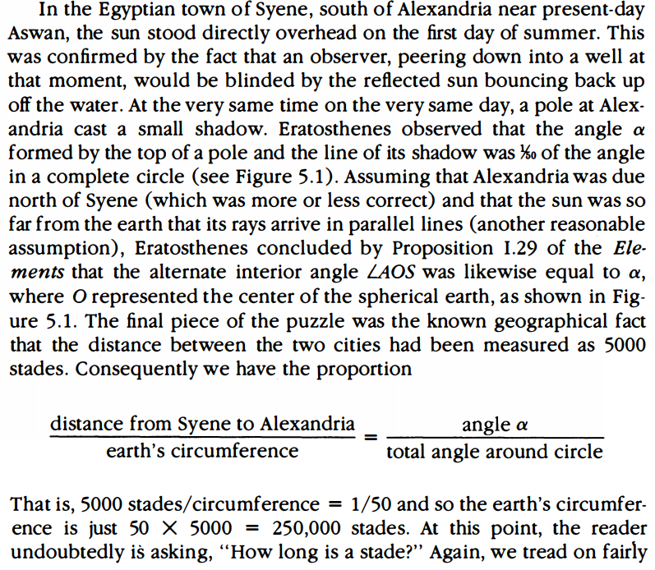

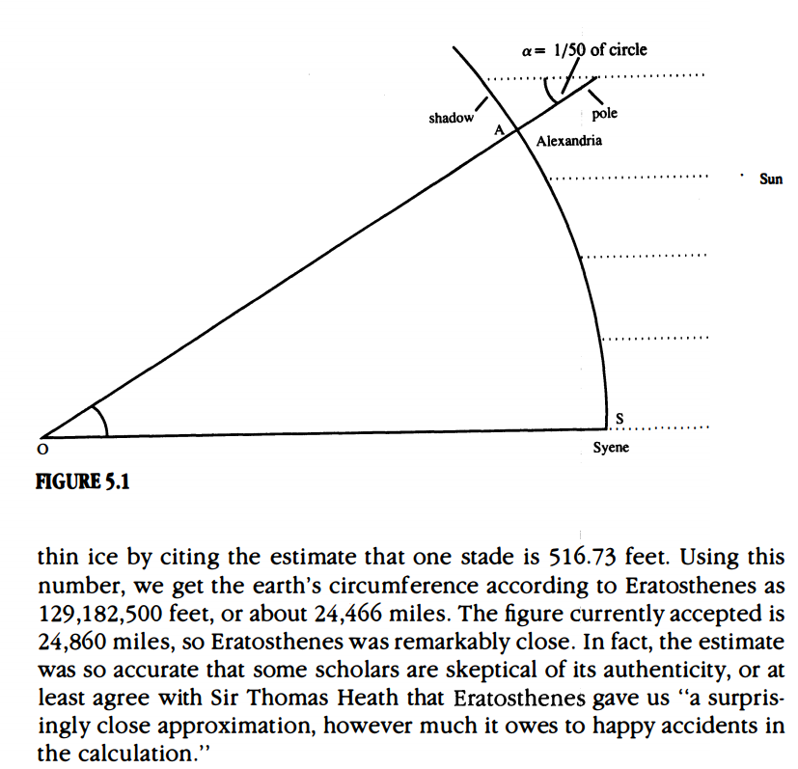

Ultimately his calculation led to about 24,466 miles, the currently accepted figure is 24,860 miles  
This figure is so close to accurate, scholars have questioned the authenticity   
What is most noteworthy is not only the accuracy of his calculation, but also the fact that, without doubt he believed the world was a sphere, when centuries (15) later European sailors feared falling off the edge of the earth.  
“If later sailors kept a keen eye peeled for the horizon’s edge, it was a symptom not of knowledge yet to be acquired but of knowledge lost” JTG 116

**Additional Suggested Reading**: N/A

**Assignment:** None